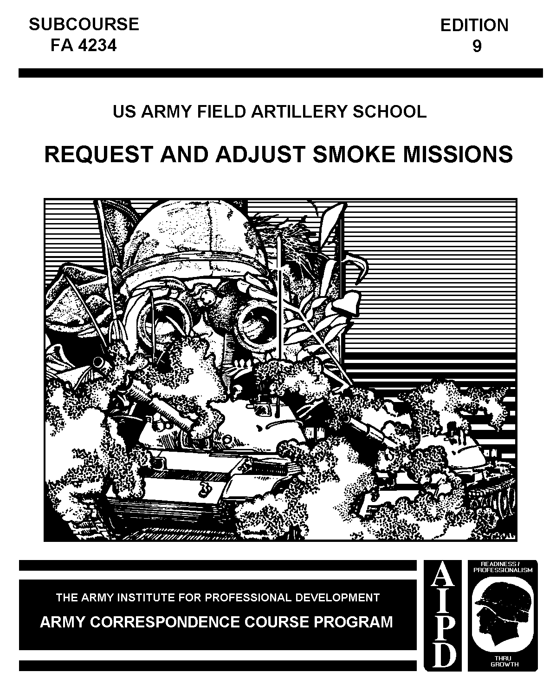

FIRE SUPPORT SPECIALIST
MOS 13F SKILL LEVEL 2

REQUEST AND ADJUST SMOKE MISSIONS

SUBCOURSE FA 4234

US Army Field Artillery School
Fort Sill, Oklahoma

Two Credit Hours

GENERAL

This subcourse is designed to train the skills necessary to request and adjust smoke missions in support of maneuver operations. This subcourse is presented in one lesson, consisting of the two tasks identified below.

TASK NO: 061-283-2021

TASK: Conduct an immediate smoke mission.

CONDITIONS: | You will be given a declinated M2 compass, binoculars, a map of the target area, communications with the FDC, a target, a digital message device (DMD) (if so equipped), and a laser range finder (LR) (if so equipped.)
STANDARDS: | Totally obscure the target using high capacity and/or white phosphorus (HC/WP) before the third round.

TASK NO: 061-283-2022

TASK: Build and maintain a quick smoke screen.

CONDITIONS: | You will be given a declinated M2 compass, binoculars, a map of the target area, communications with the FDC, a laser range finder (LR) (if so equipped), an information sheet containing a target, a situation, the ammunition available, the wind speed, and the size and duration of the smoke screen.
STANDARDS: | Deny enemy observation using HC and/or WP in accordance with FM 6-30.

W17870

TABLE OF CONTENTS

Section Page

TITLE PAGE i

TABLE OF CONTENTS ii

ADMINISTRATIVE INSTRUCTIONS iii

GRADING AND CERTIFICATION INSTRUCTIONS iii

Lesson: Request and Adjust Smoke Missions 1

Introduction 1

Employing Smoke 1

Smoke Ammunition 2

Delivery Systems 3

Delivery Techniques 3

Employment Considerations 4

Employing Immediate Smoke 9

Employing Quick Smoke 12

Summary 17

EXAMINATION E-1

* * * IMPORTANT NOTICE * * *
THE PASSING SCORE FOR ALL ACCP MATERIAL IS NOW 70%.
PLEASE DISREGARD ALL REFERENCES TO THE 75% REQUIREMENT.

ADMINISTRATIVE INSTRUCTIONS

Subcourse content. This subcourse contains one lesson related to two field artillery fire planning tasks. An introduction presents an overall view of the subject. The lesson then explains how to perform each task as it pertains to fire planning.

Supplementary requirements. The following subcourses should be completed before taking this subcourse:

a. IS0781, Map Reading.

b. FA 4024, Map Reading III.

c. FA 4201, Determine Target Locations and Directions.

d. FA 4202, Call for and Adjust Area Fire.

e. FA 4231, Special Situations.

Prerequisites are based upon skill progression solely within the correspondence course curricula. Therefore, enrollees who have acquired this included knowledge from other sources may not need to complete listed subcourses. If unable to complete this subcourse because of lack of prerequisite knowledge, request the prerequisite subcourse(s) from:

Army Correspondence Course Program
US Army Training Support Center
Newport News, VA 23628-0001
Telephone: (804) 878-2079, AUTOVON: 927-2079

Materials needed. You will need a number 2 pencil and paper to complete this subcourse (furnished by student).

Supervisory assistance. There are no supervisory requirements for completion of this subcourse.

References. No supplementary references are needed for this subcourse.

GRADING AND CERTIFICATION INSTRUCTIONS

Instructions to the student. This subcourse has an examination that is a performance-based, multiple-choice test. You must score a minimum of 75 percent on this test to meet the objectives of this subcourse.

Credit hours. Two credit hours will be awarded for successful completion of this subcourse.

Lesson
REQUEST AND ADJUST SMOKE MISSIONS

OBJECTIVE

Upon completion of this lesson, you will be able to—

- Conduct immediate smoke missions.

- Build and maintain quick smoke screens.

REFERENCES

This lesson is based on FM 6-30 and other materials approved for US Army field artillery instruction. However, development and progress render the text continually subject to change. Therefore, base your examination answers on material presented in this lesson.

1. INTRODUCTION. The effective delivery of smoke by the field artillery at the critical time and place on the battlefield may contribute to the combined arms team's accomplishment of its mission. Smoke may be used to hamper hostile operations, to deny the enemy information on friendly positions and maneuvers, and/or to reduce the ability of the enemy to deliver effective fires. As a forward observer (FO), you may be required to request and adjust both immediate and quick smoke missions.

2. EMPLOYING SMOKE. Smoke is employed to obscure enemy vision or screen maneuver elements. (Friendly units or actions are referred to in this lesson as maneuver elements or maneuver operations.)

a. Obscuring smoke. Obscuring smoke is the employment and effect of smoke targeted on or near enemy forces with the primary purpose of suppressing enemy operations. Obscuring smoke—

- Restricts the enemy counterfire program.

- Reduces the accuracy of enemy observed fire.

- Reduces the effectiveness of enemy direct-fire weapons (smoke weakens laser beams) and optically guided missiles.

- Instills apprehension and increases enemy patrolling.

- Prevents effective visual signals and increases radio traffic.

- Defeats night observation devices and reduces the capability of most infrared (IR) devices.

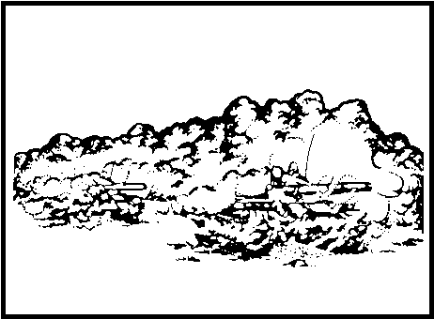
Figure 1. Obscure enemy vision.

b. Screening smoke. Screening smoke is a smoke munition employed on the battlefield between enemy and friendly units to mask maneuver operations. Screening smoke—

- Screens unit maneuvers, exposed flanks, and river operations.

- Effects deceptive screens, causing the enemy to disperse fire and waste ammunition.

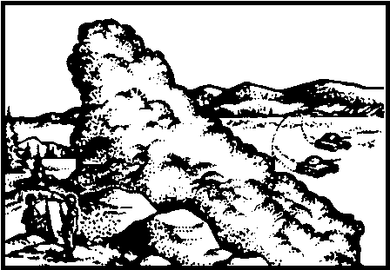
Figure 2. Screen maneuver elements.

3. SMOKE AMMUNITION. There are three smoke munitions available to the observer. Agents which produce the smoke effect are either hexachloroethane (HC) or white phosphorus (WP).

a. WP. WP is highly reactive and burns quickly to produce a smoke screen.
The effects of WP do not last as long as those of HC.

b. Smoke (HC). Smoke builds up slowly but burns longer than WP to produce the desired effects of smoke.

c. Improved smoke. Improved smoke has desirable characteristics of both WP and smoke (HC).

4. DELIVERY SYSTEMS. The weapon systems used to employ smoke are field artillery cannon and infantry mortars. Tanks also can fire WP from overwatch positions; however, their employment of smoke is generally not in the purview of the FO. Field artillery and mortar smoke capabilities and effects are at Table 1. Note the effects of wind direction, buildup times, and average burning times, which will be discussed in detail later in this lesson.

Table 1. Smoke capabilities and effects.
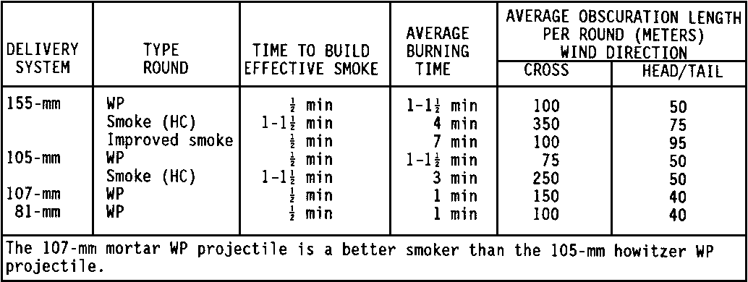

5. DELIVERY TECHNIQUES. Employment of smoke against various types of targets requires different delivery techniques. The technique is based on availability of fire support assets, types of targets, obscuration or screening time, and type of smoke munition available. Immediate and quick smoke are the two delivery techniques used by the FO.

a. Immediate smoke may be planned as a suppression-type mission, requested on an HE immediate suppression target, requested by using a shift from a planned target, or used on a grid determined at the time the FO identifies a suppression target. Immediate smoke is normally used to obscure the enemy's vision. It is effective only against pinpoint targets or a small area less than 150 meters in diameter.

b. Quick smoke may be used to obscure enemy vision or to screen the actions of friendly maneuver elements. It is employed when the urgency of the situation does not require immediate smoke or the target is too large to engage with immediate smoke. Normally, areas up to 600 meters in length may be obscured or screened by quick smoke and, under ideal conditions and downwind, may be effective for 2,000 meters or more with improved smoke.

c. Field artillery (FA) and mortars employed using these delivery techniques are shown in Table 2.

Table 2. Delivery techniques.
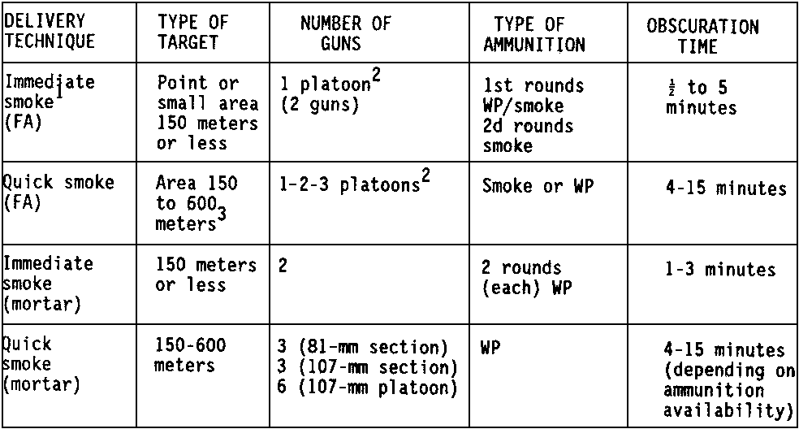

¹ The immediate smoke technique can be used in an immediate suppression mission on a target of opportunity. By unit SOP, a mix of WP and HC normally will follow the initial suppression rounds when immediate smoke is requested.
² Responsiveness dictates that both immediate and quick smoke missions be fired by platoon.
³ For larger areas, consider multiple aiming points and use of the quick smoke technique.

6. EMPLOYMENT CONSIDERATIONS. The commander's guidance determines whether smoke will be used. The commander may disallow smoke entirely, or he may allow its use at any time. The use of smoke may be contingent on a particular event or time, the crossing of a particular phase line, the accomplishment of a specified task, or some other occurrence. The FO must know, before the beginning of an operation, if and when smoke may be employed. A number of circumstances unique to smoke employment must be considered before employing smoke, such as weather, time, target location accuracy, target size, and terrain. Smoke may be planned, but changes in wind direction between planning time and time of employment must be considered. Additionally, temperature, humidity, and precipitation influence the effectiveness of smoke.

a. Weather. Weather factors influencing the effectiveness of smoke include atmosphere stability, wind speed, and wind direction.

(1) General atmospheric conditions affect smoke employment. Three smoke conditions based on temperature gradients are considered (Table 3).

Table 3. General atmospheric conditions and effect on smoke.
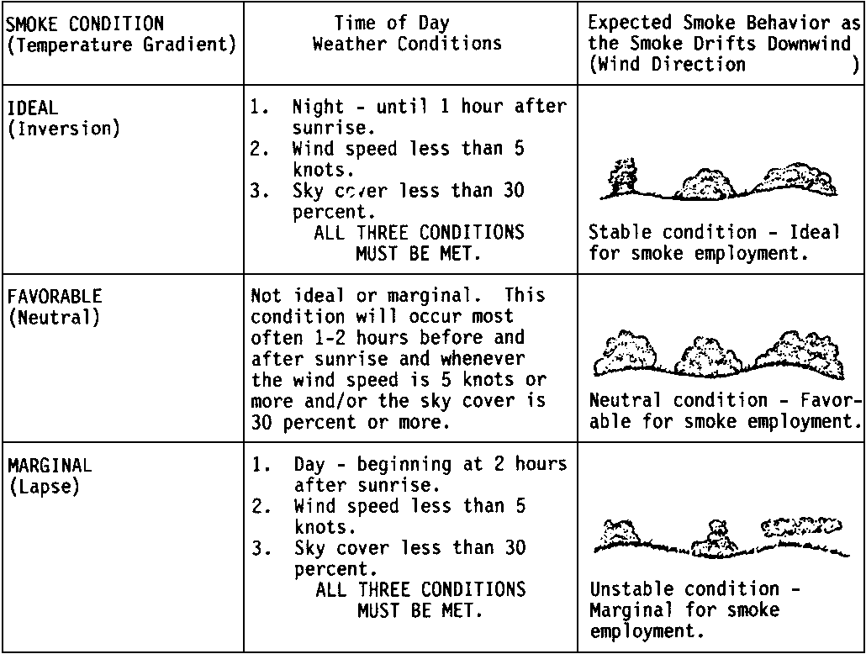

(2) Wind speed affects smoke employment. Smoke employment is most effective at wind speeds from 4 to 14 knots. The specific smoke, WP or HC, that is most effective in this range is derived from Table 4.

Table 4. Effective wind speeds for smoke employment.
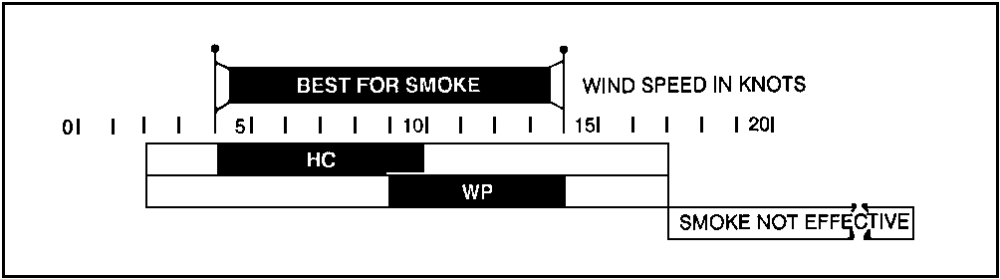

EXAMPLE: | At 6 knots, HC would be best for smoke.

(3) The FO must determine the prevailing wind speed. Through observation, wind speed estimations may be made as indicated in Table 5. Another method of estimating wind speed is the grass-drop method. When using the grass-drop method, extend the downwind arm and drop grass from the hand. Point extended arm at dropped grass on the ground. Divide by 4 the angle in degrees between the arm and the body to determine the approximate wind velocity in knots.

EXAMPLE: | When using the grass-drop method, if the FO determines the angle between arm and body to be 45°, the angle is then divided by 4 and a wind speed of 11 knots is determined.

Table 5. Equivalent wind scale table by observation.
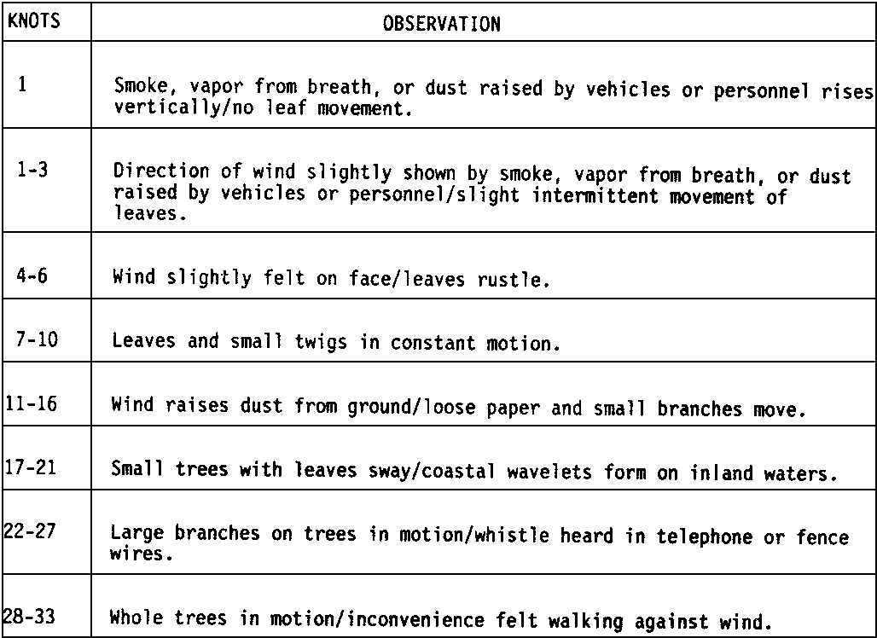

(4) Wind direction is critical when selecting the adjusting point for smoke. The FO must determine the wind direction in relation to the maneuver-target line. The maneuver-target (MT) line is an imaginary line that extends from the maneuver unit to the target. The maneuver-target line may begin at the friendly position or at any vulnerable point along a friendly unit's route of march. The end of the MT line is at the center of the enemy position. Wind direction in relation to the maneuver-target line is expressed only in terms of head, tail, or cross winds. The FO must determine which wind effect is most

prominent in relation to the maneuver-target line. See Figure 3. Care must be used with head winds, since the smoke may be blown onto the maneuver element. If the wind is a crosswind, the smoke is placed upwind to screen the enemy's vision along the maneuver-target line. If the wind is a tail wind, the smoke is placed at least 200 meters short of the target to prevent the smoke from drifting beyond the target before maximum buildup.

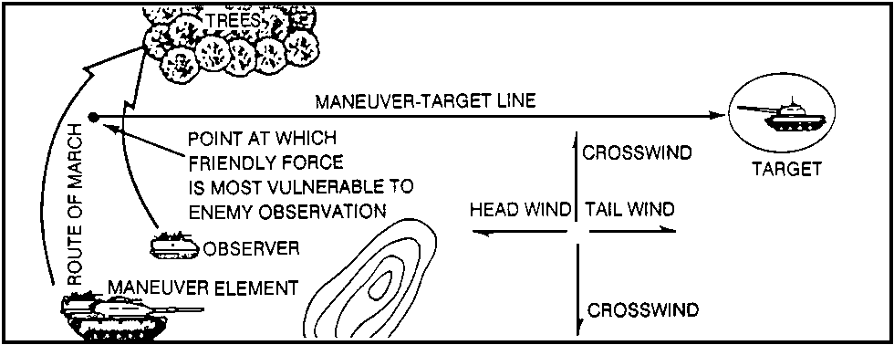
Figure 3. Determining the maneuver-target line.

EXAMPLE: | The FO determines a maneuver-target line as indicated in Figure 4. The wind effects on the maneuver-target line are mostly crosswind effects.

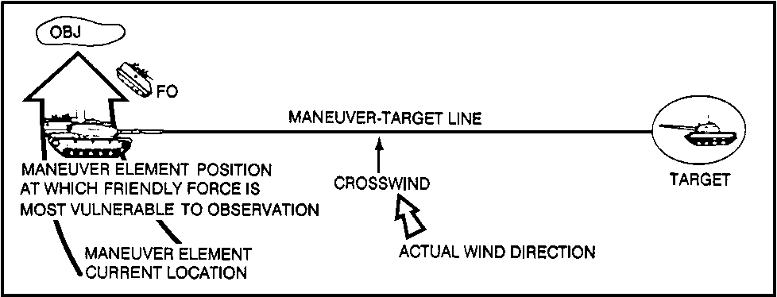
Figure 4. Placing smoke in a crosswind.

b. Length and attitude of the quick smoke screen. Quick smoke must be placed relative to the target to be screened. Hence, we describe a desired smoke screen in terms of length and attitude. The length is the length in meters to be screened. Length may depend on the enemy size or the friendly unit's vulnerability to observation. Attitude is described as a clockwise angle, in mils, measured from grid north to a line passing through the long axis of the enemy position. Attitude will not exceed 3,200 mils. See Figure 5. Length of smoke may be longer than target length based on the estimates of the commander.

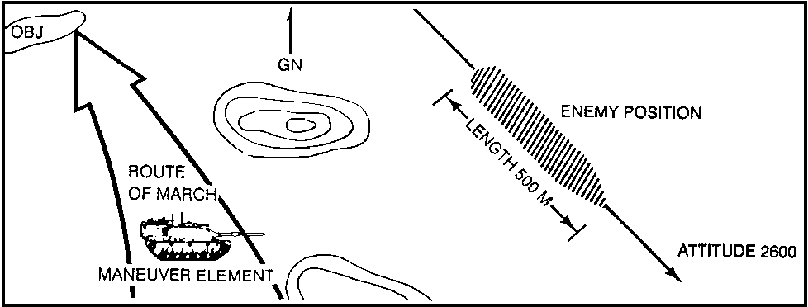
Figure 5. Length and attitude.

c. Time. Time is another important factor in the use of smoke. If time is not on the FO's side, it may be necessary to disregard wind factors and fire smoke directly on the enemy position. Partial screening immediately may be more desirable than complete screening a little later. Smoke will not suppress a target as rapidly as HE; however, the suppression may last longer. WP can be expected to obscure the target within 30 seconds and has an average burning time of 1 to 1 1/2 minutes. HC will require 1 to 1 1/2 minutes to build up and burns an average of 4 minutes. The FO must observe the smoke and request additional rounds as needed to ensure the target is suppressed for the required length of time. During the initial buildup of smoke, the FO must make alternative plans for attacking the target with other FA munitions or inform the maneuver element commander of the firing battery's inability to suppress the target for a prolonged period of time.

d. Other considerations.

(1) Temperature, humidity, and precipitation affect smoke employment. Higher temperatures cause smoke to dissipate more rapidly, while higher humidity or precipitation increases smoke effectiveness.

(2) Terrain is a consideration when employing smoke. HC should not be used on steep slopes. The smoke canisters will roll downhill and be ineffective. Another consideration of terrain is the possibility of undesirable fires. In dry, wooded, or grass areas, smoke may start fires that could hinder maneuver forces. Smoke may not function properly in mud, water, or deep snow.

PRACTICE EXERCISES:

Complete the following exercises by circling T for true or F for false, circling the letter preceding the correct answer, or filling in the blanks, as appropriate. Be sure to complete the practice exercises as they appear. They are "building blocks" and will help you complete the rest of the subcourse successfully. The answers follow the last exercise and are separated by rows of slashes (////). If any of your answers are incorrect, restudy the appropriate part of the subcourse before you continue.

1. Smoke placed directly on or near the enemy to suppress enemy operations by minimizing the enemy's vision and causing confusion is called ____________ ______________________ smoke.

2. A smoke curtain to mask maneuver operations or to deceive the enemy is called _______________________ smoke.

3. The decision to use smoke is made by the _________________________.

4. HC smoke should not be employed on steep slopes because __________ ______________________ _______________.

5. Mud, water, and snow cause smoke to be ___________________________. (effective, ineffective)

6. Time to build effective HC smoke for both 155-mm and 105-mm is ___________ to ___________________ minutes.

7. Type of round for the mortar delivery system is ___________________.

//////////////////////////////////////////////////////////////////////////////////////////////////////////////////////////////////////////////////////////////////

ANSWERS:

1. obscuring
2. screening
3. commander.
4. the canisters will roll.
5. ineffective.
6. 1, 1 1/2
7. WP.

//////////////////////////////////////////////////////////////////////////////////////////////////////////////////////////////////////////////////////////////////

7. EMPLOYING IMMEDIATE SMOKE. Immediate smoke may be requested as suppression or immediate suppression missions. The FO often relies on high-explosive (HE) fires to suppress targets; however, immediate smoke may provide suppression for a longer period of time. Smoke should not be requested initially if SOP requires HE in the loading tray. Instead of changing the ammunition, the observer should request a fire mission to use the SOP suppression rounds as adjusting rounds and then call for immediate smoke. Unit SOPs usually require that one gun fire WP for the first round in an immediate smoke mission while the other gun fires HC

smoke. A mixture of WP and HC smoke will be effective approximately 30 seconds after the smoke fuzes function and will last 4 to 5 minutes. If more smoke is required, both guns will fire HC in subsequent volleys unless the FO requests WP.

a. Call for fire. The call for fire for immediate smoke is much shorter than the call for fire for other fire. Immediate smoke is effective only against small, pinpoint targets or areas less than 150 meters.

EXAMPLES: | If immediate smoke was previously planned, the call for fire is—

THIS IS H24, SUPPRESS AT2301, OVER.

If immediate smoke is the continuation of an HE immediate suppression mission, the call for fire is—

THIS IS H24, IMMEDIATE SMOKE, DIRECTION 5600*, RIGHT 200, ADD 400, REPEAT, OVER.

*If direction is not sent previously in immediate suppression mission.

If the observer wants obscuring smoke on a planned, immediate suppression target (HE), target number AB4031, the call for fire is—

THIS IS H24, IMMEDIATE SMOKE, AB4031 OVER.

NOTE: | The initial volley will be the prepared high explosive (HE) as the FDC computes shell smoke data.

If the FO identifies a target that can be located by grid coordinates, the call for fire is—

THIS IS H24, IMMEDIATE SMOKE, GRID 628543, OVER.

b. Selection of adjusting points for immediate smoke. The target itself is not the adjusting point for smoke missions. The FO must offset the effects of wind direction in order to achieve the desired smoke effects on the target. If the FO were to place the smoke directly on the target, for example, in a 10-knot crosswind, the smoke would probably not obscure the target for more than a few seconds. Table 6 is used to offset the effects of wind and select an appropriate adjusting point. The FO must determine the wind direction in relation to the MT line and extract correction values.

Table 6. Adjusting points for immediate smoke.
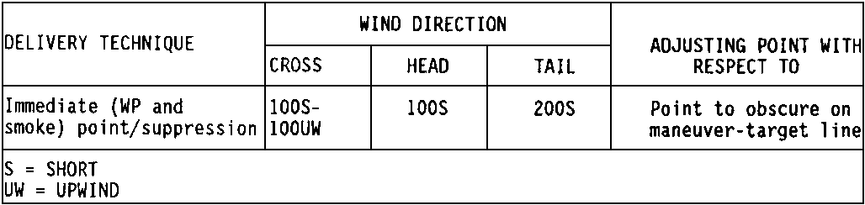

EXAMPLE: | The FO determines the maneuver-target line based on the commander's guidance. Wind direction is tail wind. The FO enters the table and extracts the value 200 S. He must therefore select his adjusting point 200 short of the target on the maneuver-target line (Figure 6).

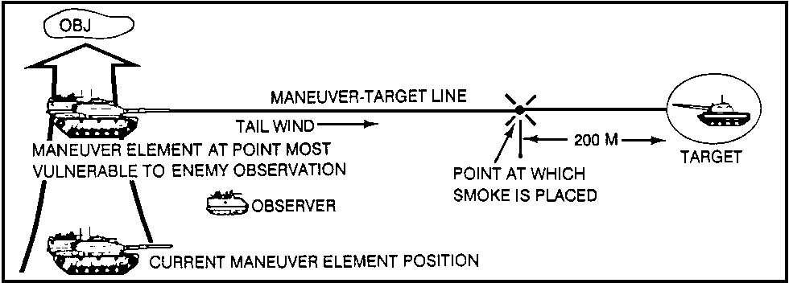
Figure 6. Placement of immediate smoke.

c. Subsequent corrections for immediate smoke. If immediate smoke is ineffective or partially effective, the FO may adjust the smoke for range, deviation, and height of burst. The minimum correction for range is 100 meters, and the minimum correction for deviation is 50 meters. Height must be adjusted as follows:

Ground burst: UP 100
Canisters bouncing: UP 50
Canisters too spread out: DOWN 50*

*To determine whether the canisters are too spread out, observe to see whether the smoke is properly placed but ineffective. If this happens, the height must be adjusted accordingly. When adjusting smoke, the FO must keep in mind that while observing on the observer-target (OT) line, the smoke must be adjusted on the maneuver-target line if they are not the same.

EXAMPLE: | If the smoke was not effective and not on the adjusting point, the FO makes the appropriate correction for range, deviation, and height. His correction may be DIRECTION 6050, LEFT 100, ADD 200, UP 50, REPEAT, OVER.

PRACTICE EXERCISES:

8. | To illustrate the proper placement of smoke, the map below shows the FO's position (grid square 0011), a maneuver element (grid square 0111), and an enemy OP (grid square 0109) to be obscured. The commander wants the OP obscured given that the maneuver platoon's current position is the most vulnerable point. Select the adjustment point.

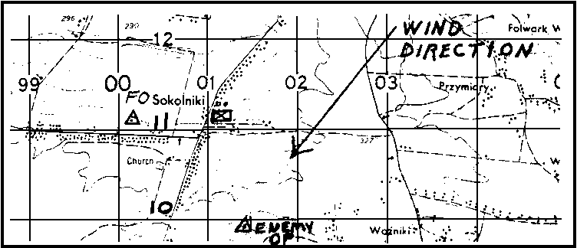

9. | Write your call for fire here.

//////////////////////////////////////////////////////////////////////////////////////////////////////////////////////////////////////////////////////////////////

ANSWERS:

8. Using the information in the appropriate table, the FO selects a point 100 meters short of the enemy OP and 100 meters upwind. The correct point for placement of the smoke is indicated by the tick mark at grid 014101.
9. THIS IS H24, IMMEDIATE SMOKE, GRID 014101, OVER.

//////////////////////////////////////////////////////////////////////////////////////////////////////////////////////////////////////////////////////////////////

8. EMPLOYING QUICK SMOKE. The FO employs quick smoke to obscure the enemy's vision or screen friendly maneuver actions. Weather is usually a more important consideration for quick smoke than for immediate smoke. Partial obscurity is acceptable when employing immediate smoke to obscure the enemy; but quick smoke, when used to screen maneuver elements, must completely screen to be effective. The FO must know the employment considerations discussed in paragraph 6 so he can advise the commander on whether or not quick smoke is possible. Once the decision to employ quick smoke is made, the FO must determine the appropriate adjusting point and other critical information the fire direction center needs to fire a quick smoke mission.

a. Length and attitude. Quick smoke requirements are described as linear, irregularly shaped targets. Based on the size of the enemy position and the maneuver element's route of march, a smoke screen length must be determined. In addition, the desired smoke screen attitude, based on terrain considerations and enemy positions, must be determined.

b. Wind direction. Wind direction, expressed as a crosswind, head wind, or tail wind, in relation to the MT line must be determined.

c. Time. The maneuver commander's guidance will normally include the time, or duration, of the desired smoke screen.

d. Selecting a quick smoke adjusting point. As in immediate smoke, the FO must determine an appropriate adjusting point. Table 7 is used.

Table 7. Adjusting points for quick smoke.
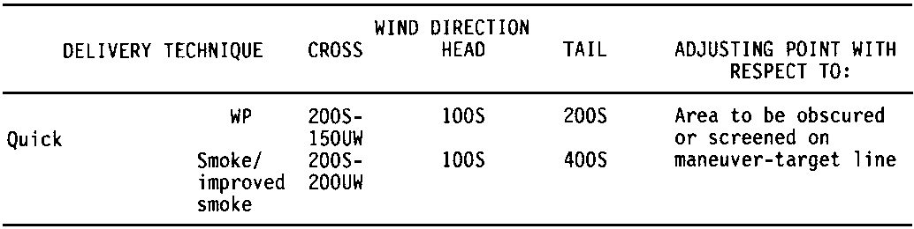

EXAMPLE: | The FO determines the maneuver-target line based on the most vulnerable point of the route of march and the enemy's location. Wind direction affects the MT line as a crosswind. Wind speed is 6 knots, so smoke (HC) is the desired munition. From Table 7, the FO determines the adjusting point to be 200 M short (S) and 200 M upwind (UW) from the target in relation to the MT line. See Figure 7. The commander desires smoke for 10 minutes.

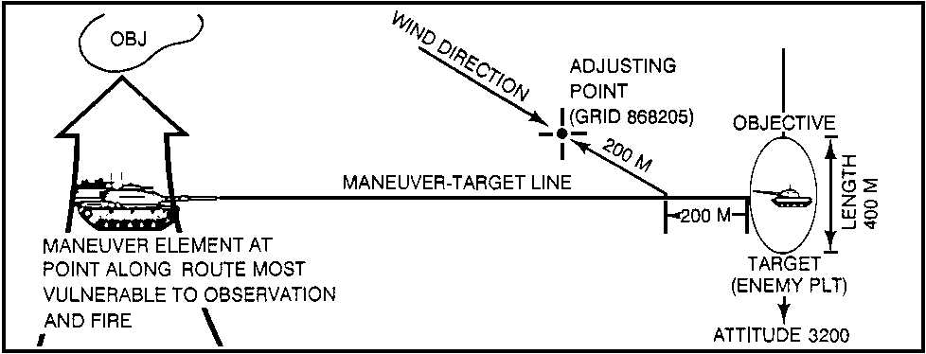
Figure 7. Determining an adjusting point for quick smoke.

e. The quick smoke call for fire. A quick smoke call for fire is normally sent in three transmissions as any adjust-fire mission. The third transmission, however, provides the FDC with the necessary information to calculate data for the smoke screen. The order of information is:

- Target description.

- Length in meters.

- Attitude in mils.

- Wind direction expressed as head wind, tail wind, or crosswind.

- Duration of smoke in minutes.

- Type of smoke in effect (WP or HC smoke).

EXAMPLE: | From the example in Figure 7, the FO has all the information necessary to send his call for fire:

H18 THIS IS H24, ADJUST FIRE, OVER.

GRID 868205, OVER.

PLATOON POSITION, 400 METERS, ATTITUDE 3200, CROSSWIND, DURATION 10 MINUTES, SMOKE IN EFFECT, OVER.

PRACTICE EXERCISE:

10. | Determine the call for fire for the following mission. Write your answers in the space provided below.
 | You are the FO located with the platoon in grid square 9821. The platoon leader has requested a smoke screen in front of the village of Konstantynow (grid square 9822) extending the entire length of the village for 10 minutes. Konstantynow is situated along an attitude of 1800 and is 1000 meters in length. This will allow the platoon to maneuver to the west to grid 970210. The most vulnerable point along the route is grid 973212. The direction of wind is indicated by the arrow in grid square 9922. Call signs are FO—Y18 and FDC—Y57. Wind speed is 5 knots. Determine the call for fire for this mission.

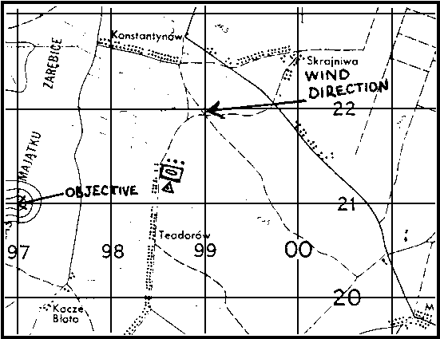

The call for fire is: __________________________________________________________________________________________
__________________________________________________________________________________________

//////////////////////////////////////////////////////////////////////////////////////////////////////////////////////////////////////////////////////////////////

ANSWER:

 | 10. | Y57 THIS IS Y18, ADJUST FIRE, OVER.
 |  | GRID 984225, OVER.
 |  | COMPANY POSITION, 1,000 METERS, ATTITUDE 1,800
 |  | CROSSWIND, DURATION 10 MINUTES, SMOKE IN EFFECT, OVER.

//////////////////////////////////////////////////////////////////////////////////////////////////////////////////////////////////////////////////////////////////

f. Adjusting quick smoke. Adjustment is normally started with shell HE; and as the FO nears the selected adjustment point, he calls for shell smoke in adjustment.

NOTE: | The adjusting point is determined in relation to the MT line not the observer-target (OT) line. In smoke adjust missions, the FO must not confuse the two.

(1) In a quick smoke mission, the HE adjustment phase may be conducted without prior approval to save time; however, no smoke may be fired until approval is granted. The adjustment for a quick smoke screen using HE, fuze quick, avoids obscuring the adjusting point. When shell HE is adjusted to within 100 meters of the adjusting point, the FO calls for shell smoke in the adjustment.

EXAMPLE: | THIS IS H18, SHELL SMOKE, RIGHT 60, DROP 100, OVER.

(2) The FO then adjusts for range, deviation, and height of burst as outlined for immediate smoke missions. When approval for smoke is given and the FO has placed smoke on the adjusting point, fire for effect is entered. It is best to have an effective screen developed at the same time the manuver element begins the operation requiring the screen. To do this, the observer requests the firing unit to fire AT MY COMMAND and requests the time of flight. Refer to Table 1 (time to build effective smoke), and add the time of flight to determine the amount of time before the operation to fire.

EXAMPLE: | The subsequent correction sent to the FDC should be: AT MY COMMAND, FIRE FOR EFFECT, REQUEST TIME OF FLIGHT, OVER. From Table 1, the FO determines buildup time for 155-mm smoke to be 1 minute, and the FDC sends a time of flight of 17 seconds. Add the two figures to determine the time to fire before the manuver unit leaves its present location—1 minute and 17 seconds. Smoke will be effective as the unit commences operations.

g. Maintaining or correcting quick smoke. The FDC will determine the number of guns or platoons to fire quick smoke missions as well as the volume of smoke fires. These data are based on assumed standard conditions. Actual buildup times and smoke volley durations may vary. The FO is the best judge of the effects of smoke on the battlefield. By observing how long a smoke volley remains effective and how long it took to build up, the FO can determine an actual interval between each volley. If smoke interval correction or continuation of smoke is desired, the FO requests this smoke by announcing the interval determined and the additional time desired. The correct interval is determined by subtracting the buildup time from the effective screen time and then rounding down to the nearest whole minute to ensure that there are no gaps in the smoke screen.

Interval = Effective Screen Time - Buildup Time.

EXAMPLE: | Actual buildup time for a smoke screen volley was observed to be 1/2 minute, and the volley was effective for 2 minutes. Interval = 2 - 1/2 = 1 1/2, expressed to 1 minute. If the commander desires an additional 5 minutes of smoke, the FO sends the following subsequent correction to the FDC:
 | CONTINUE SMOKE AT 1-MINUTE INTERVALS FOR 5 MINUTES.

h. Second adjusting point. At times, one adjusting point, length, and attitude may not adequately describe the smoke cover the commander desires. A second adjusting point can be selected.

(1) Remember, the FDC selects the number of guns or platoons to screen the target. When the weapons have fired, the FO may find that the entire length of the area to be screened is not covered. To correct this problem, the FO can request additional fire to cover the entire length of the target area. If all howitzers are firing on the screen, the FO must select a second aiming point (grid) or shift the screen. If the area can be screened by the use of two aiming points, the FO determines the shifts from the initial aiming point and transmits his request for a second aiming point.

EXAMPLES: | THIS IS H18, SECOND AIMING POINT, LEFT 400, ADD 300, REPEAT, OVER.
 | This tells the FDC that smoke must be replenished on both aiming points at the time interval determined by the FO. If the FO determines that simply shifting the screen will be effective, the transmission is—
 | THIS IS H18, LEFT 400, ADD 300, REPEAT, OVER.

(2) In either case above, the FO must realize there is a possibility of a break in the screen while new data are computed. Finally, the FO must watch for holes and gaps in the screen. It may be necessary to adjust a particular weapon individually or to increase the rate of replenishment to fill in areas of the screen.

PRACTICE EXERCISE:

11. | A quick smoke screen is adjusted to within ______________________ meters of the adjusting point.
12. | Time to build effective smoke added to ___________ ______ _______ determines time before the operation the unit should fire.
13. | You have determined that to maintain an effective screen you must use a second aiming point 500 meters left of the initial aiming point and 200 meters short. Your call sign is H18. What is the next transmission?
14. | You determined an actual smoke buildup time of 1 1/2 minutes and an effective screen duration of 5 minutes per volley. What is the replenishment interval you would send to the FDC?

//////////////////////////////////////////////////////////////////////////////////////////////////////////////////////////////////////////////////////////////////

ANSWERS:

11. 100
12. time of flight
13. THIS IS H18, LEFT 500, DROP 200, REPEAT, OVER.
14. 3 minutes (5 - 1 1/2 = 3 1/2, expressed down to 3)

//////////////////////////////////////////////////////////////////////////////////////////////////////////////////////////////////////////////////////////////////

9. SUMMARY. Effective delivery of smoke contributes significantly to the accomplishment of the mission of the combined arms team. Smoke employment is a detailed process requiring close coordination between the maneuvered commander and the forward observer (FO). To be able to provide the commander sound and timely advice on smoke employment, the FO must be fully knowledgeable on this subject. This lesson covers the necessary smoke employment considerations and the procedures used for immediate and quick smoke operations.

